Name

Answers

1. ____________

2.

3.

4.

5.

6.

7.

8.

Homework Section 8.9

Chapter

8

**Identify each figure formed by the net then find its surface area.**

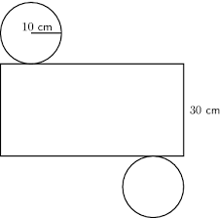

**1-2.**

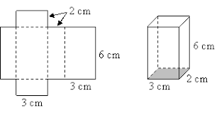**3-4.**

**Draw a net for each figure below.**

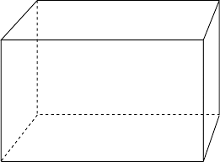

**5.**

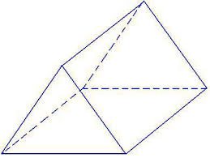

**6.**

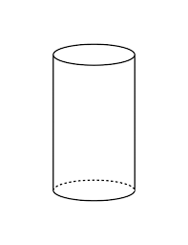**7.**



**8.**

**Find the surface area of each prism.**

Answers

9. ____________

10.

11.

12.

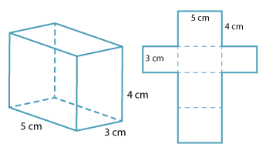

**9.**

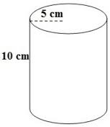

**10.**

12 cm

3 cm

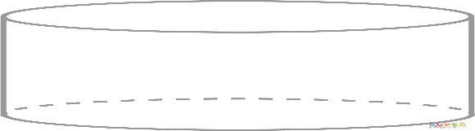

**11.**

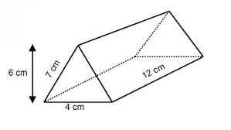

**12.**