Name

Answers

1. ______________

2.

3.

4.

5.

6.

7.

8.

9.

Homework Section 8.8

Chapter

8

**Name each figure.**

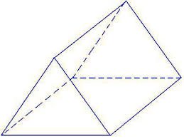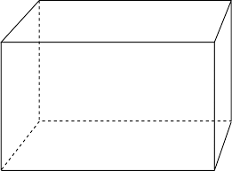**1. 2.**

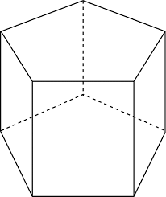

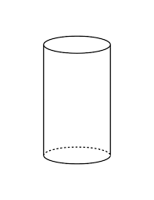**3. 4.**

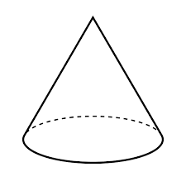

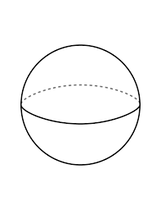**5. 6.**

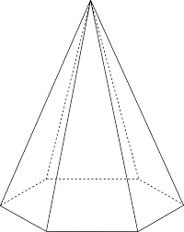

**7. 8.**

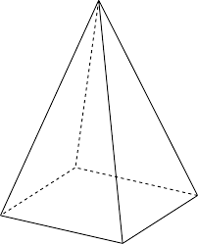**9.**