Name
Answers
1. _____________
________________
2.
___________________
3.
___________________
4.
___________________
5.
___________________
6.
___________________
7.
___________________

Homework Section 8.5
Chapter
8
Find the circumference and area of each circle. Round to the nearest tenth.

1.
50 cm

2.
17 mm

3.

27 m

4.
40 in

5.
7 cm

6.

8 m

7.

6 in

8.
10 m

9.
25 cm

10.
Answers
8. _____________
________________
9.
___________________
10.
___________________
11.
___________________
12.

30 ft

11.
22 cm

12.
15 km

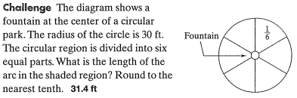
13.

