Name
Answers
1. _____________
2.
3.
4.
5.
6.
7.
8.
9.
10.
11.

Homework Section 8.2
Chapter
8
Find the area of the parallelogram.
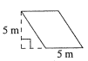
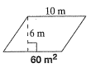
1. 2.

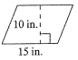
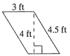
3. 4.

Find each area for base b and height h of a parallelogram.
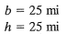
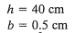
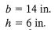
5. 6. 7.

Find the missing measures for each rectangle.
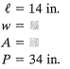
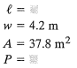
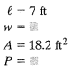
8. 9. 10.

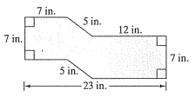
11. Find the area and perimeter of the figure to the right.

