Name
Answers
1. ____________
2.
3.
4.
5.
6.
7.
8.

Homework Section 8.10
Chapter
8
Find the volume of each figure. Round to the neareat tenth if
necessary.

5in
5.5in

5.5in
6cm

2cm

2cm

8m

1. 2.

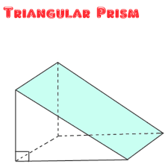
13 in

6m

7m

8m

7ft

7.5 ft

7.5ft

3. 4.

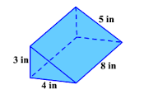
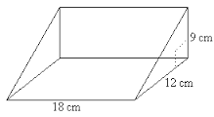
5. 6.

2 in

7 in
13 cm

33 cm
7. 8.

9.
7in

8 in

2 6

5
10.

