Name
Homework Section 4.5
Chapter
4
Evaluate each expression for the given value of the variable.
Answers
1.
2.
3.
4.
5.
6.
7.
8.
9.
10.

1. $4m-6.5:m=2$ 2. $12-3b: =4.3$

3. $5y-5:y=5$ 4. $2p+4.5;p=5.1$

Solve each equation using number sense.
5. $4m+12=52$ 6. $10h+14=84$

7. $7w+16=37$ 8. $5v+19=24$

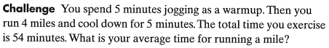
9.

