Name
Homework Section 4.3
Chapter
4
Solve each equation. Check your answer.
Answers
1.
2.
3.
4.
5.
6.
7.
8.
9.
10.
11.
12.
13.
14.
15.
16.
17.
___________________

1. $x-6= -55$ 2. n – 255 = -455

3. $-83.4+m=122$ 4. $t-32.8= -27$

5. $h-37= -42$ 6. $q-16=40$

7. $k+17=29$ 8. $d+261.9= -48$

9. $x+34=212$ 10. $253+c=725$

11. $89+y=100$ 12. $62.5+t= -77$

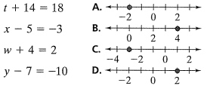
13.
14.
15.
16.

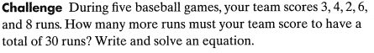
17.

