Name
Homework Section 4.2
Chapter
4
Find the solution of the equation from the given numbers.
Answers
1.
2.
3.
4.
5.
6.
7.
8.
9.
10.
11.
12.
13.
14.
15.

1. $p + 17 = 56; 29, 39 or 49$ 2. $\frac{y}{9}=32;261, 279 or 288$

3. $6d= -36.6; -6.1, 0 or 6.1$ 4. $n-27=38;11, 51 or 65$

Use mental math to solve each equation.
5. $n+4=7.9$ 6. $4d= -32$

7. $\frac{p}{5}=3.1$ 8. $24= -6w$

9. $\frac{c}{-3}=8$ 10. $z-8.4=0$

Estimate the solution of each equation to the nearest whole number.
11. $3.1g=20.9$ 12. $h-4.9=13.8$

13. $7.8+n=38.2$

14.

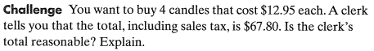
15.

