Name Date

Homework Section 3.7

Chapter

3

Choose the most precise measurement.

Answers

1.

2.

3.

4.

5.

6.

7.

8.

9.

10.

11.

12.

13.

1. 13 cm, 13 mm **2.** 8.5 kg, 2.25 kg



3. 30 g, 2.5 kg 4. 25 qt, 38 pt

5. lb, 6.37 lb 6. 0.25 g, 101 mg

**Find the greatest precision possible for each scale shown.**

**7.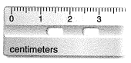 8.**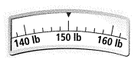

Find each sum or difference. Round your answer to the appropriate precision.

9. 10.

11. 12.

13. 