Name Date
Mixed Numbers and Improper
Fractions
Answers
1.
2.
3.
4.
5.
6.
7.
8.
9.
10.
11.
12.
13.

2.5

Write each number as an improper fraction$.$
1. $2\frac{3}{8}$ 2. $5\frac{3}{4}$

3. $1\frac{1}{12}$ 4. $1\frac{3}{7}$

5. $3\frac{2}{5}$ 6. $5\frac{2}{3}$

Write each improper fraction as a mixed number in simplest form.
7. $\frac{16}{3}$ 8. $\frac{25}{3}$

9. $\frac{31}{12}$ 10. $\frac{28}{6}$

11. $\frac{40}{6}$ 12. $\frac{48}{11}$

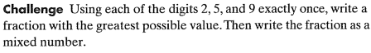
13.

