Name Date
Answers
1.
2.
3.
4.
5.
6.
7.
8.
9.
10.
11.
12.
13.
14.
15.

2.2

Prime Factorization

Is the number prime or composite?
1. $37$ 2. $50$

3. $23$ 4. $63$

Find the LCM of each pair of numbers.
5. $9,12$ 6. 2,5

7. $5, 10$ 8. $24, 8$

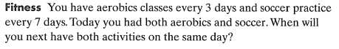
9.

Find the factors of each number.
10. $20$ 11. $23$

12. $32$ 13. 62

14. $93$ 15. 43

16. 91 17. 63

Write the prime factorization of the following numbers.
18. 45 19. 84

20. 52 21. 60

Find the GFC of the following pairs of numbers.
22. 18, 32 23. 16, 80

24. 38, 76 25. 54, 80

26.

