Name Date
Homework Section 10.3
Chapter
10
Find the slope of each line.
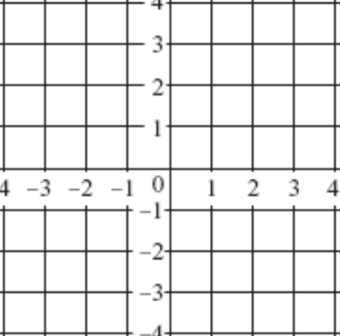
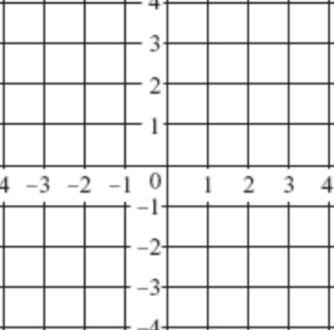
1. 2.

3.

Draw a line with the given slope through the given point.
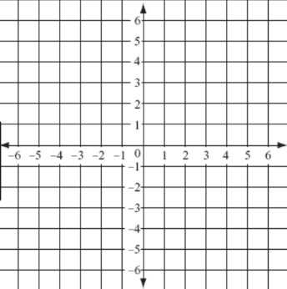
4. P(0,0), slope = -3

5. R(6,6), slope = $\frac{5}{2}$

Graph the given points and find the slope of a line through the points.
6. (4,8),(5,10) 7. (4,-1),(-4,1)

8. (2,7),(3,-1)

9. On the same coordinate plane, graph r through points (0,4) and (3,-3) and s through points (1,7) and (4,0). Find the slopes of r and s. Are these slopes parallel?

