Name Date
Homework Section 10.2
Chapter
10
Use the equation y = x – 7 for 1-9.
Answers
1-9. see table
10.
11.
12.
13.
14.
15.
16.

x | x – 7 | y | (x,y)
0
-3
10
1-9. Complete the table.

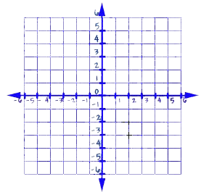
10. Graph the equation.

11. Is (-1,6) a solution of the equation.

12. Is (5,-2) a solution of the equation.

Find three solutions to each equation.
13. y = x – 2

14. y = x

15. y = 5x

Answers
16.
17.
18.
19.
20.
21. see graph
22. see graph
23. see graph
24. see graph
25.

16. y = 3x + 1

Tell if ordered pair is a solution of y = x + 12.
17. (-12, 24) 18. (0,-12)

19. (7,19) 20. (6,15)

Graph each equation.
21. y = x – 1 22. y = 3x

23. y = x +4 24. y = 2 – x

25. Does the graph of the equation y = x – 5 passes through the second quadrant. Explain.

