Name Date
Homework Section 10.1
Chapter
10
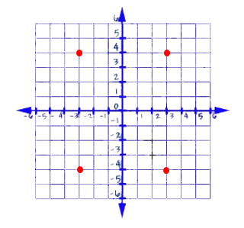
Match each point with its coordinate.
1. J A. (3,4)
2. K B. (-3,4)
3. L C. (3,-4)
4. M D. (-3,-4)
5. Which axis in a coordinate plane is vertical? Which is horizontal?

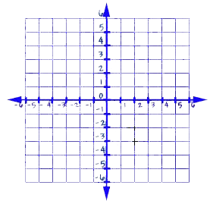
Label each point on the given coordinate plane and name the quadrant for each point.
6. G (-2,2)
7. H (2,-3)
8. J (3,0)
9. K (4,4)
10. L (-3,-4)
11. M (-4,1)
12. N (1,3)
13. P (0,-2)

