Name Date
Answers
1.
2.
3.
4.
5.
6.
7.
8.
9.
10.
11.
12.
13.

1.5

Metric System
Write the number that makes the statement true.
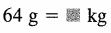
1. 2. 302 mL = L

3. 8,490 mm = km 4. 0.9 kg = g

5. 90 mL = L 6. 58 m = mm

7. 7,800 g = kg 8. 7 m = km

9. 240 kL = L

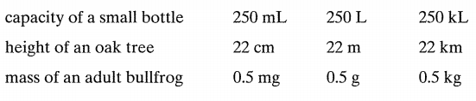
Choose a reasonable estimate.
10-12.

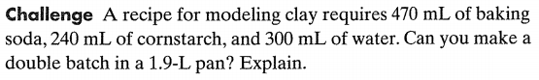
13.

