Name Date
Answers
1.
2.
3.
4.
5.
6.
7.
8.
9.
10.
11.
12.
13.

1.3

Multiplying Decimals

Find each product.
1. 0.4 x 0.6 2. 1.02 x 3.6

3. 1.45 x 2.6 4. 1.3 x 0.5

5. 1.1 x 1.1 6. 1.3 x 0.05

Find each product. Use mental math.
7. 0.2 x 3.41 x 5 8. (2.3 x 0.5) x 4

9. 0 x 2.78 x 1 10. 0.4 x (0.5 x 0.2)

11. 7.1 x 6.2 x 3.5 x 0

12. If you are riding a bike at 3.5 mi/h, how far will you travel in 1.2 h?

13. A penny weighs about 0.1 oz. How much is a pound of pennies worth? (1pound= 16 oz.)

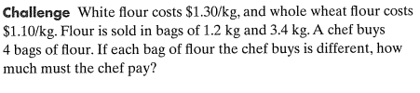
14.

